

Baldivis Secondary College

Semester One Examination, 2017

Question/Answer Booklet

MATHEMATICS
Year 10 Pathway 2

Calculator-assumed

Name:

Time allowed for this section
Reading time before commencing work: 5 minutes
Working time for section: 50 minutes

Materials required/recommended for this section
To be provided by the supervisor
This Question/Answer Booklet
Yellow Formula Sheet

To be provided by the candidate
Standard items: pens (blue/black preferred), pencils (including coloured), sharpener, correction fluid/tape, eraser, ruler, highlighters

Special items: notes on one unfolded sheets of A4 paper, and up to three calculators approved for use in the WACE examinations

Important note to candidates
No other items may be taken into the examination room. It is your responsibility to ensure that you do not have any unauthorised notes or other items of a non-personal nature in the examination room. If you have any unauthorised material with you, hand it to the supervisor before reading any further.

Structure of this paper

Section | Number of questions available | Number of questions to be answered | Working  time (minutes) | Marks available | Percentage of exam
Section Two:  Calculator-assumed | 9 | 9 | 50 | 52 | 100
 |  |  | Total | 54 | 100

Instructions to candidates

- The rules for the conduct of examinations are detailed in the school handbook. Sitting this examination implies that you agree to abide by these rules.

- Write your answers in this Question/Answer Booklet.

- You must be careful to confine your response to the specific question asked and to follow any instructions that are specified to a particular question.

- Spare pages are included at the end of this booklet. They can be used for planning your responses and/or as additional space if required to continue an answer.
- Planning: If you use the spare pages for planning, indicate this clearly at the top of the page.
- Continuing an answer: If you need to use the space to continue an answer, indicate in the original answer space where the answer is continued, i.e. give the page number. Fill in the number of the question that you are continuing to answer at the top of the page.

- Show all your working clearly. Your working should be in sufficient detail to allow your answers to be checked readily and for marks to be awarded for reasoning. Incorrect answers given without supporting reasoning cannot be allocated any marks. For any question or part question worth more than two marks, valid working or justification is required to receive full marks. If you repeat any question, ensure that you cancel the answer you do not wish to have marked.

- It is recommended that you do not use pencil, except in diagrams.

- Your Formula Sheet is not to be handed in with your Question/Answer Booklet.

Question 1 (1, 1, 1, 1, 2 = 6 marks)
Simplify the following:
- $5^{4}×5^{2}=$

- $4^{9}÷4^{5}=$

- $3^{0}×2=$

- ${\left(5^{7}\right)}^{3}=$

- $\frac{8{ab}^{-3}}{-4a^{-2}b}$

Question 2 (4, 4 = 8 marks)
Find the area of these shapes:

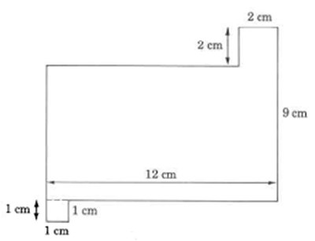
b)

Question 3 (2, 2 = 4 marks)
Find the volume of these solids to the nearest whole number:

(a)
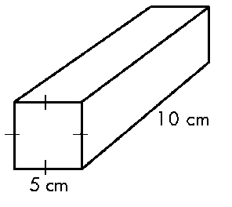

(b)
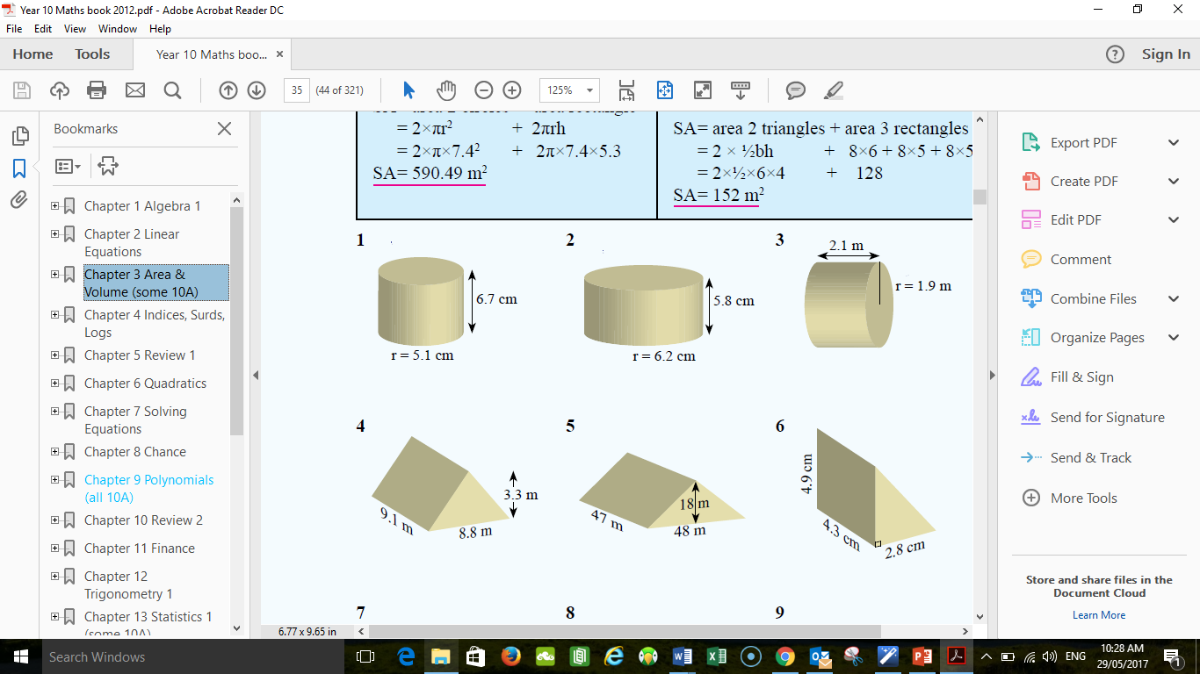

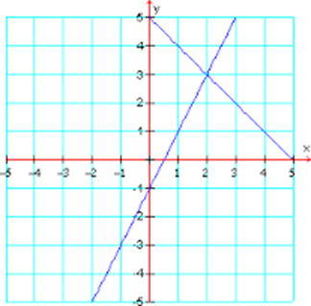
Question 4 (2, 5 = 7 marks)
- Solve this pair of simultaneous equations

- Solve this pair of simultaneous equations by completing the table of values and graphing
$y=4x$ and $y=-x+5$

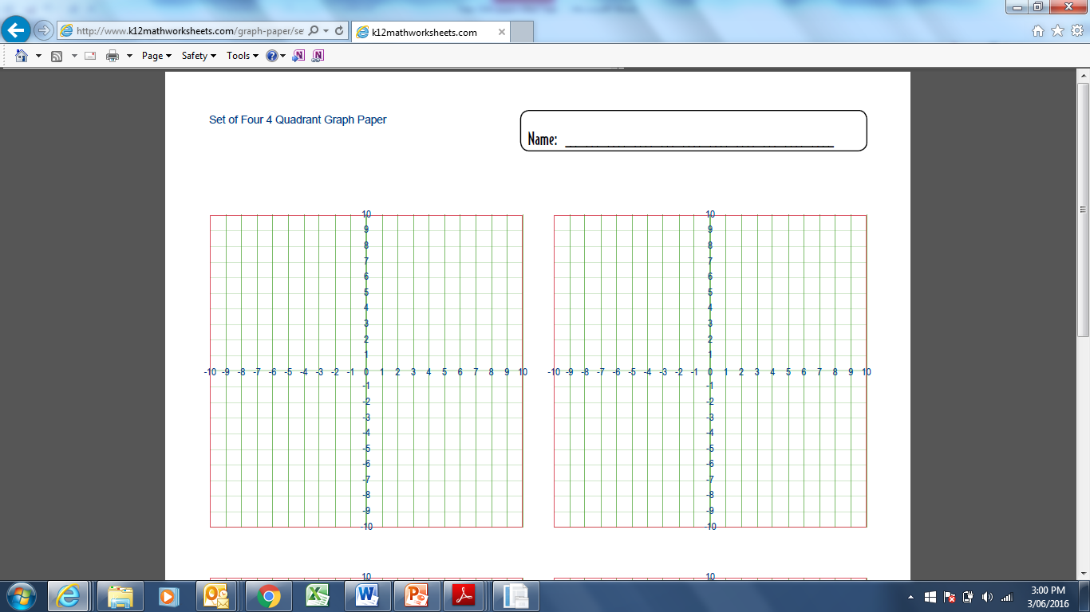

Question 5 (5)
What is the surface area of a cylinder 8 m long and 5 m in diameter? Answer correct to two decimal places. hint: draw a diagram

Question 6 (1, 2, 2 = 5 marks)
Expand the following

- $3\left(x+2\right)$

- $g(g-6)$

- ${4t}^{2}({3t}^{3}+2v)$

Question 7 (1, 2 = 3 marks)
Factorise the following expressions:
- 4x + 8

(b) 5x² + 10xy

Question 8 (3, 2, 2 = 7 marks)
A jar contains 2 blue, 2 red and 2 white marbles. Two marbes are then chosen at random without replacement.
- Draw a simplified tree diagram to show the sample space.

- What is the probability that they will both be the same colour?

- What is the probability that lat lease one will be yellow?

Question 9 (3, 2, 2 = 7 marks)
In a survey of 50 coffee drinkers, 33 have milk. 11 have sugar with their coffee and 8 have both milk and sugar.
- Draw a venn diagram to represent this data

- Find the probability that a coffee drinker has neither milk nor sugar

- Find the probability that a coffee drinker has sugar given that they use milk.

END OF TEST

